Gun Firing Control Circuit:

Parts used:
-Lm741 op-amp from Radio Shack
-2 10k potentiometers
-2 68ohm resistors
-9v 12A SPDT relay from Radio Shack
9v nominal coil voltage
10mA nominal coil current
500 ohm coil resistance

Circuit Information:
When the R70 Airsoft gun was purchased we noticed that it used a simple on/off switch to control when the firing motor would activate. When the user would squeeze the trigger a spring would close the switch so that the gun would fire. To emulate this functionality and be able to control when the gun would fire we chose to implement a circuit based around a relay that would be able to handle the high amount (5+ A) of current that the gun will pull from the battery pack.

We used the following circuit configuration for the firing circuit:
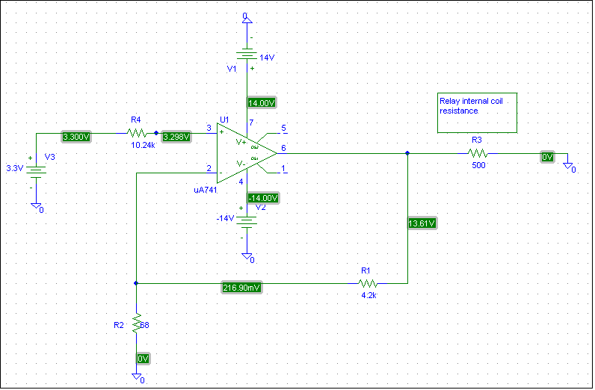

The circuit was arranged into a non-inverting amplifier setup with a gain of ~3 to obtain at least 9v at the output of the op-amp. Once the voltage gain was determined then the output current had to be at least 18mA when the circuit was activated. If the current was any lower then the relay coil might not trip and change its state. This was deduced from the formula of Gain = 1+ (R1 / R2). Originally R1 was set to have a value of 400ohms but operationally we found that a potentiometer set at ~4.2k yielded the gain that we wanted to see from the output. Additionally, a resistor was added to the input with a high enough resistance so that any current and voltage flow at the input would be reduced when the input voltage was near 0v. If we did not include the input resistor then the relay would never switch between states when the input voltage changed from 3.3v to near 0v.

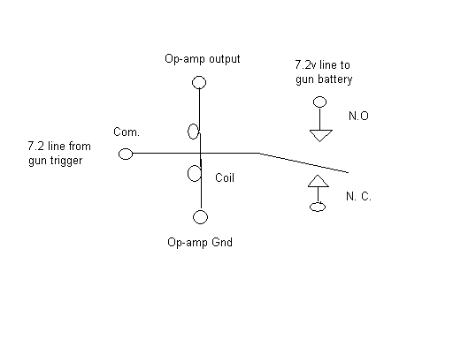

To wire the SPDT relay into the firing circuit we did not use the normally closed relay output. For the common relay input we spliced the 7.2v positive terminal of the battery and fed one end to that terminal and the other to the normally open terminal of the relay. This makes it so that whenever the IO8 output from the Xbee controller changes then the relay will open at 3.3v (will fire) and close (will not fire) at 0v.

